CS 255 System Design Document Template

Erik Olsen

UML Diagrams

UML Use Case Diagram
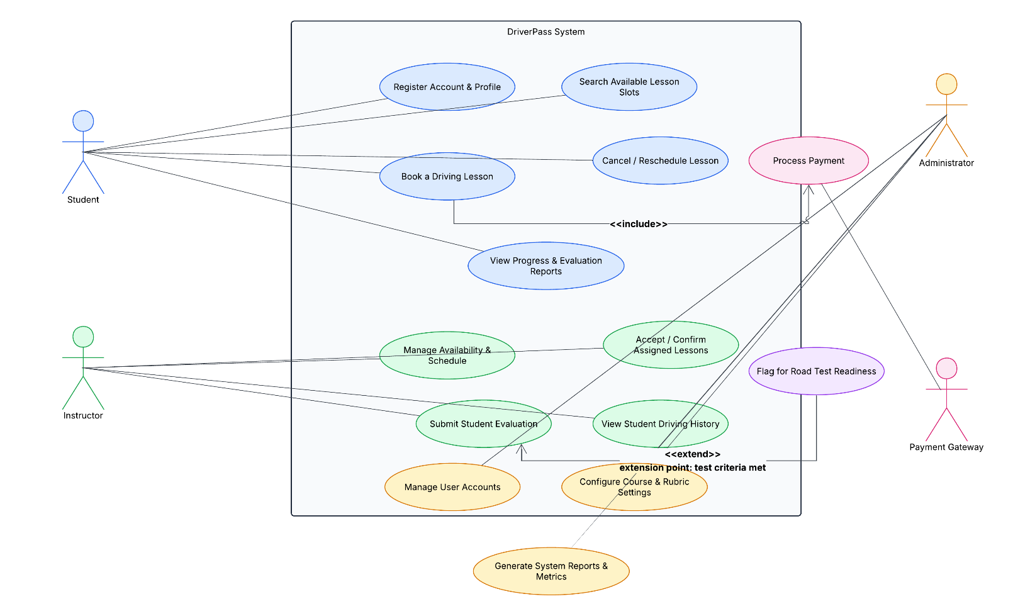

UML Activity Diagrams
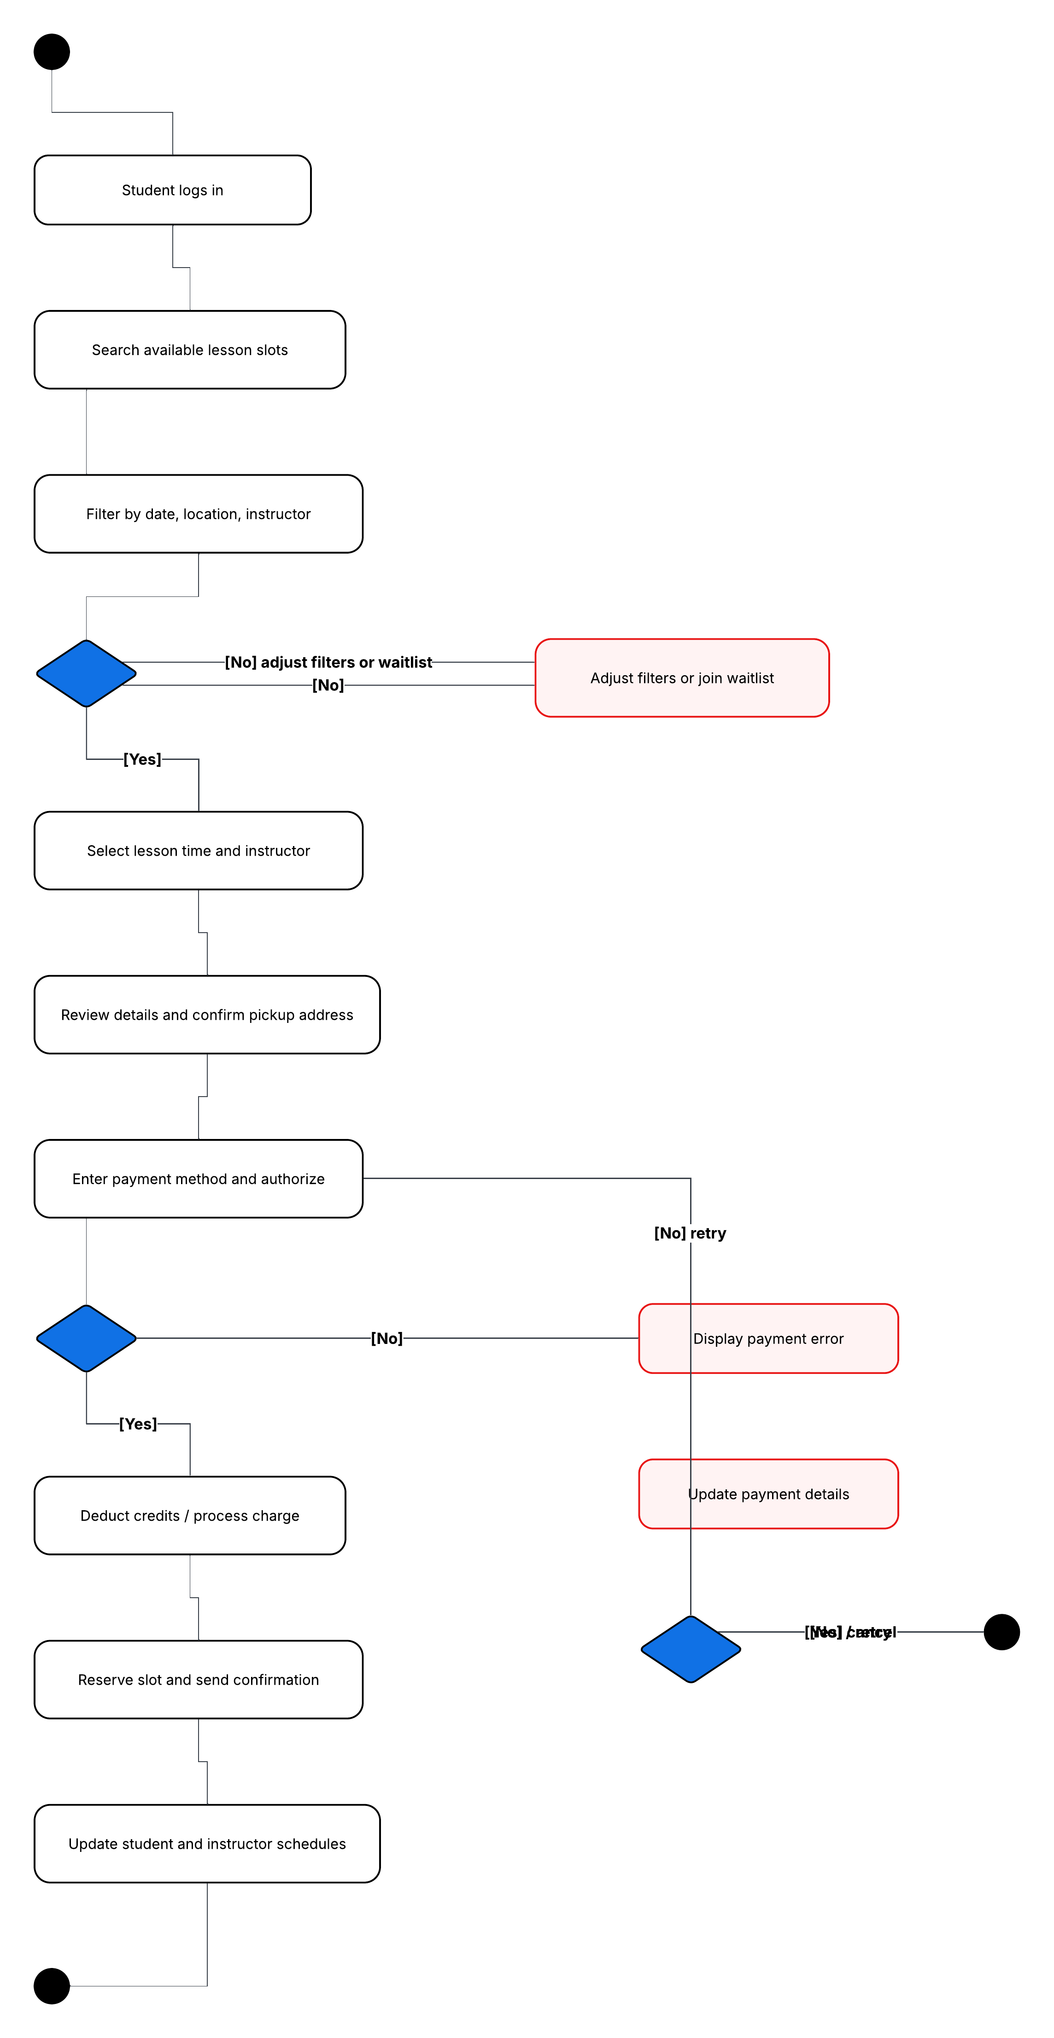
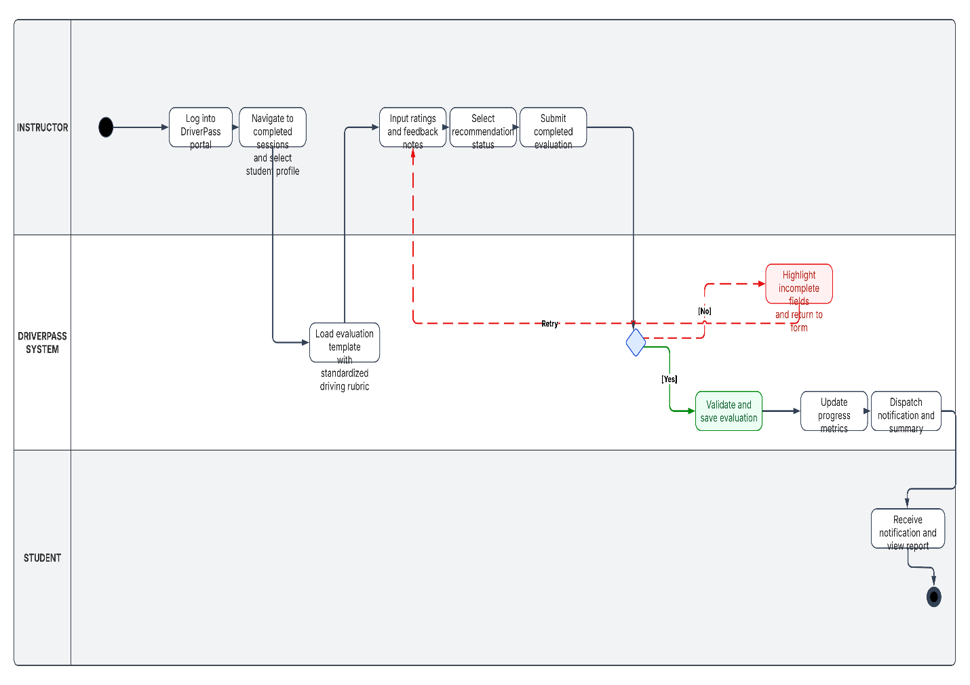

UML Sequence Diagram

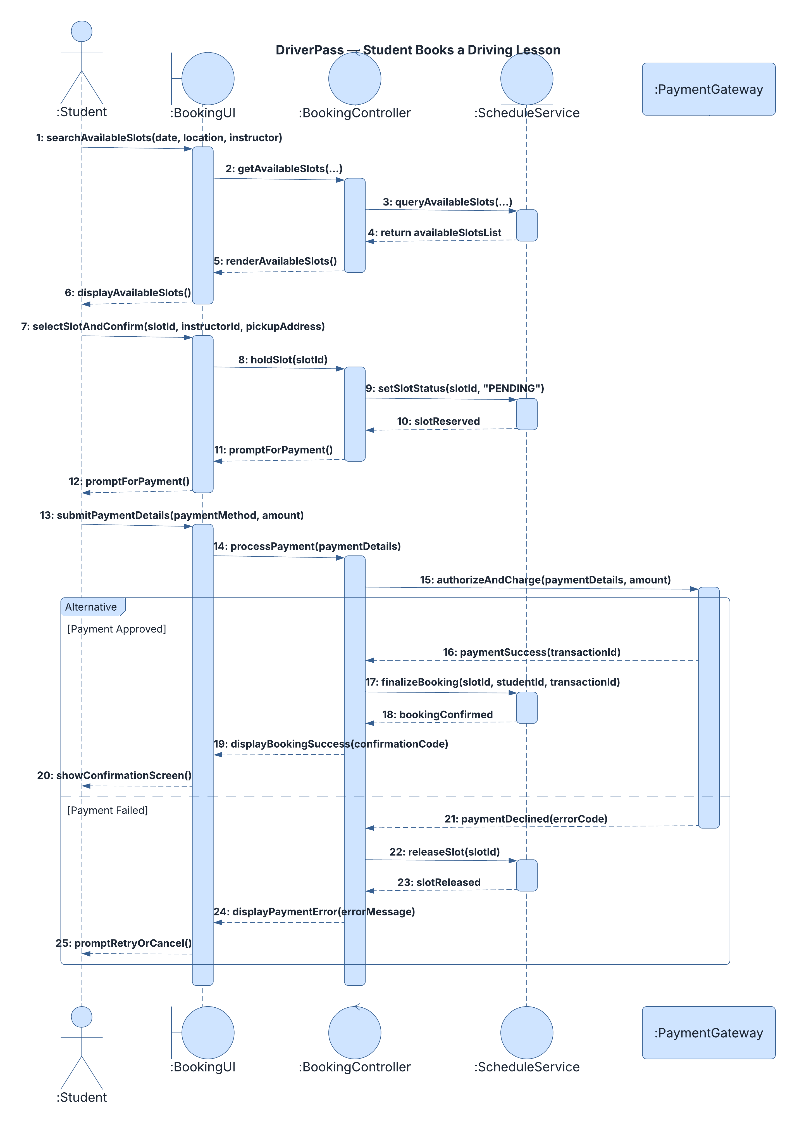UML Class Diagram
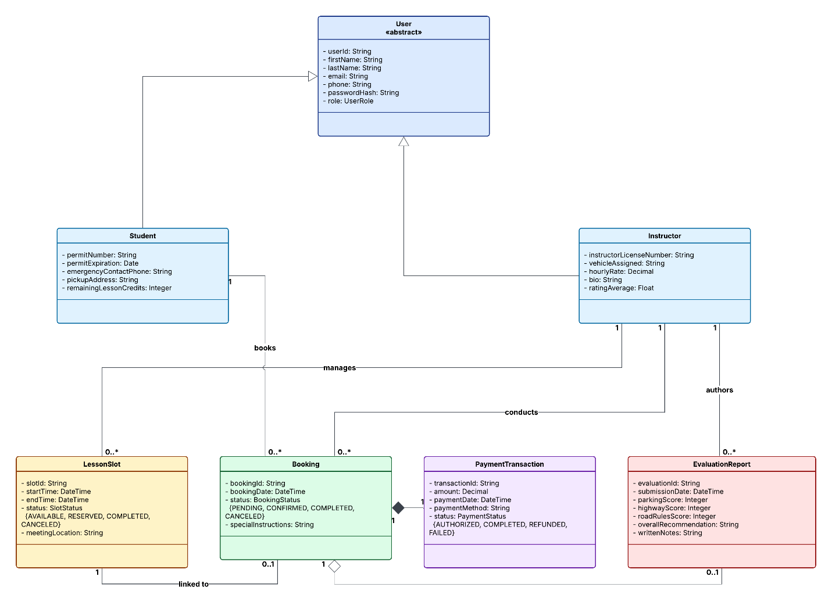

Technical Requirements
[Based on the diagrams you have created, describe the technical requirements of your system. These requirements should address the required hardware, software, tools, and infrastructure necessary for your system design.]

The DriverPass management system is structured as a cloud-hosted, multi-tier web application designed to fulfill the functional needs of self-service lesson scheduling, secure transaction processing, real-time schedule synchronization, and standardized student evaluations. To support the operational flows and data relationships identified in the UML design models, the technical requirements encompass four primary pillars: hardware, software, development tools/third-party integrations, and cloud infrastructure.
- Hardware Requirements
  - End-User Client Devices:
    - Students and Instructors: Web browsers accessible on modern desktop/laptop computers (Windows, macOS, Linux, ChromeOS) and mobile devices (smartphones and tablets running iOS 15+ or Android 10+) to support booking on the go and in-vehicle rubric submissions.
    - DriverPass Administrative Staff: Standard office desktop or laptop systems with dual-monitor capability recommended for concurrent schedule and roster oversight.
  - Server and Host Infrastructure:
    - Rather than physical on-premise hardware, the system leverages virtualized cloud hardware instances to guarantee high availability and elastic resource allocation.
    - Application Server Profile: Clustered virtual compute instances configured with automatic horizontal scaling to handle traffic spikes during registration and scheduling windows.
    - Database Host Profile: Managed database compute nodes configured in primary-replica pairings across separate availability zones.
- Software Requirements
  - Client / Presentation Layer:
    - Modern standards-compliant web browsers supporting HTML5, CSS3, JavaScript (ES6+), and WebSocket protocols (Google Chrome 110+, Mozilla Firefox 110+, Apple Safari 15+, and Microsoft Edge 110+).
    - Responsive Single Page Application SPA framework to provide instantaneous calendar filtering, real-time slot selection, and mobile-friendly form controls for the driving evaluation rubric.
  - Application / Logic Layer:
    - Server runtime environment hosting the RESTful / GraphQL API services that back the BookingController and ScheduleService identified in the sequence model.
    - Asynchronous background job processor to handle non-blocking dispatch of SMS and email confirmations, slot hold expiration timers, and batch reporting.
  - Data Storage Layer:
    - Relational Database Management System (RDBMS): PostgreSQL 15+ to enforce relational integrity, referential constraints, and ACID transactions across User, Student, Instructor, Booking, and PaymentTransaction tables.
    - In-Memory Cache and Session Store: Redis 7+ used for distributed session management, low-latency caching of instructor availability calendars, and atomic locks on LessonSlot status transitions.
- Tools and Third-Party Integrations
  - CASE and Design Tools:
    - Lucidchart for architectural diagramming (Use Case, Activity, Sequence, and Class models) and system documentation maintenance.
  - Payment Processing Gateway:
    - PCI-DSS Level 1 compliant gateway integration utilizing tokenized client-side elements. Credit card data bypasses DriverPass servers entirely, fulfilling strict financial security and compliance mandates while handling authorization, capture, and refund workflows.
  - Automated Notification Service:
    - Third-party transactional messaging APIs to dispatch immediate booking confirmations, schedule cancellation notices, and student evaluation summaries.
  - Development and Build Pipeline:
    - Version Control: Git with GitHub or GitLab enterprise repositories.
    - CI/CD Pipeline: GitHub Actions or Jenkins automating container builds, linting, unit testing, and zero-downtime deployment workflows.
    - API Specifications and Testing: OpenAPI / Swagger documentation framework paired with Postman for integration test suites.
- Infrastructure and Deployment Requirements
  - Cloud Hosting Environment:
    - Deployed on a major Public Cloud Platform within a high-speed Virtual Private Cloud (VPC).
    - Containerization and Orchestration: Application microservices packaged via Docker containers and managed using managed Kubernetes or serverless container platforms to support rapid rollouts and dynamic auto-scaling.
  - Networking and Traffic Districution:
    - Application Load Balancer (ALB): Terminates TLS/SSL certificates and distributes incoming HTTPS traffic evenly across healthy application instances.
    - Content Delivery Network (CDN): Global edge caching for static assets to reduce server load and latency.
  - Security and Access Control:
    - Transport and Storage Encryption: Mandatory HTTPS/TLS 1.3 encryption for all data in transit; AES-256 encryption for all rest across all database instances, storage volumes, and database backup snapshots.
    - Authentication and Authorization: Role-Based Access Control (RBAC) enforced via OAuth 2.0 / JSON Web Tokens (JWT), segregating access privileges strictly between Student, Instructor, and administrative accounts.
    - Security Perimeter: Web Application Firewall (WAF) to inspect traffic against SQL injection, cross-site scripting (XSS), and automated DDoS attempts.
  - Backup, Disaster Recovery and Monitoring:
    - Automated daily snapshots of relational databases with multi-region replication and point-in-time recovery (PITR) with an RPO of < 15 minutes and RTO of < 2 hours.
    - Centralized logging and real-time application performance monitoring tracking system uptime, API response latencies, error rates, and failed transaction events.

